Pages 91-92 and Page 113 ***Java Programming A Comprehensive Introduction***

**Section 1: Define / Answer**

How does a **for** loop with multiple loop control variables operate?

the first pass of the outer loop triggers the inner loop, which executes to completion. Then the second pass of the outer loop triggers the inner loop again. This repeats until the outer loop finishes.

Explain the the execution of the following Nested **for** loops

for (int i = 1; i < 5; i++){

System.out.println("Outer Loop " + i);

for (int j = 1; j < i; j++, j++)

System.out.println("Inner Loop " + j);

The following Nested for loops will go to the outer loop first, and print the first string of the outer loop.

Next, it will go to the inner loop and finish the loop/print all the strings and back to the outer loop again, and print the second string of the outer loop.

And it will keep continue until the outer loop finish.

**Programming Assignments**

**1st Task-** Expanding the **for** loop. PG. 116 #17 in Java Programming *A Comprehensive Introduction*

Write a program that uses a **for** loop to print a list of 100 numbers consisting of alternating 1’s and -1’s, starting with 1.

Use 2 loop control variables.

Sample Output from System.out.println

i = 1 / j = -1

i = 2 / j = -2

i = 3 / j = -3

i = 4 / j = -4

i = 5 / j = -5

i = 6 / j = -6

i = 7 / j = -7

i = 8 / j = -8

i = 9 / j = -9

i = 10 / j = -10

**cont…**

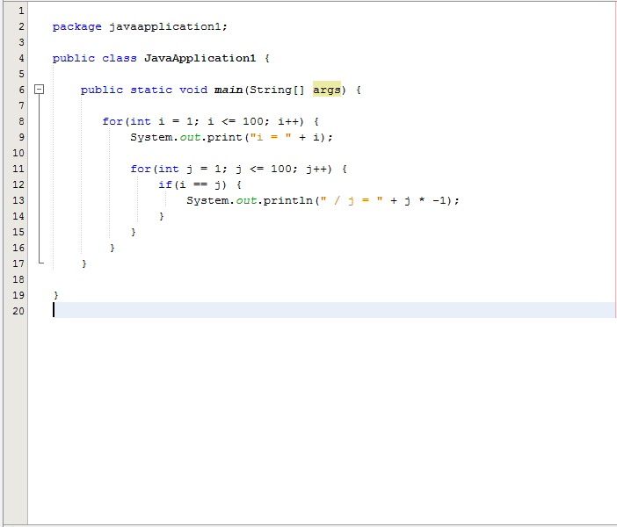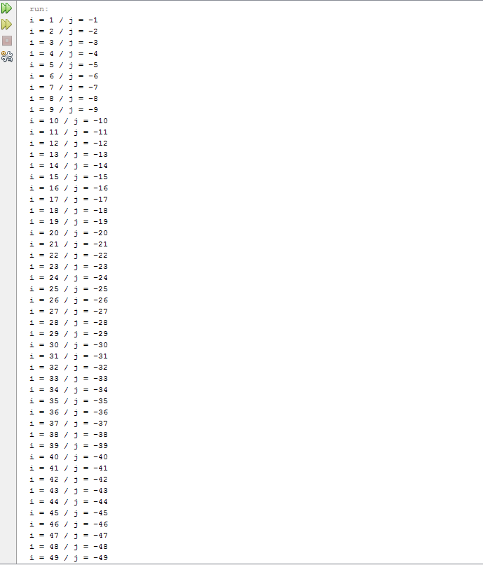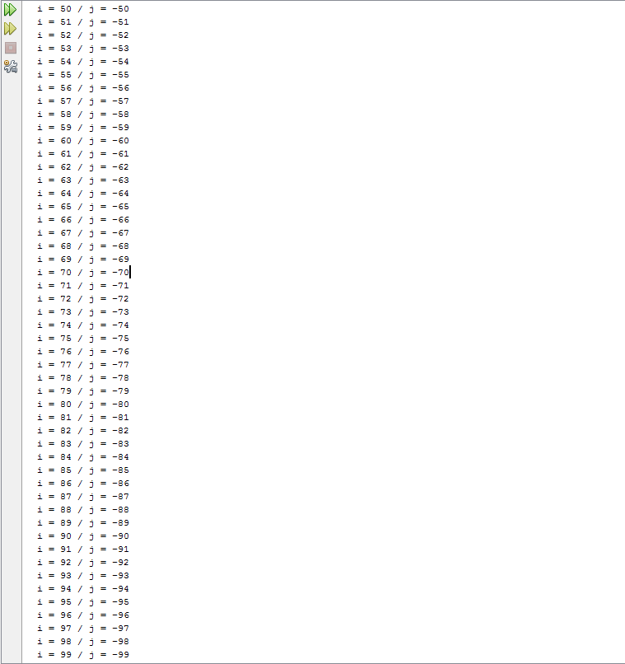

**2nd Task-**

Create a multiplication table for numbers 1 – 9,and all the multiples up to 9.

Use a Nested **for** Loop to print the table.

**Formatting is key for this assignment**, your output should exactly match the output below.

Expected Output

Multiplication Table

1 2 3 4 5 6 7 8 9

---------------------------------------------------------

1| 1 2 3 4 5 6 7 8 9

2| 2 4 6 8 10 12 14 16 18

3| 3 6 9 12 15 18 21 24 27

4| 4 8 12 16 20 24 28 32 36

5| 5 10 15 20 25 30 35 40 45

1| 6 12 18 24 30 36 42 48 54

Etc...

